Florida Light and Power
Image Recognition for Pad Mounted Equipment

Functional Decomposition

Senior Design – Team 304:
Kent Logue
Jordan Wilkerson
Sam Hammermaster
Erin Murphy
Gage Irwin

Date:
September 29th, 2021

Functional Decomposition
Introduction
The functional decomposition breaks down the major functions, systems, procedures, or processes of the project into smaller parts. The functional decomposition describes outcomes and physical actions. These parts should meaningfully reflect the original system. More importantly, functional decomposition does not specify solutions, components, or equations.

Data Generation
During the analysis of the key goals, assumptions, and customer needs, the question of interest was “What is the main objective and what functions are needed to solve it?” The main objective was then expanded upon, by starting with major functions and breaking them down to form a hierarchy of functions shown in the flowchart below. The primary objective of the project is to locate pad-mounted transformers where a fault has occurred. This can be broken down into two main parts: the software and hardware. The software is an image recognition system and the hardware is a physical beacon. The primary purpose of the hardware for this project is simply to output a signal the software can detect. The occurrence of this signal is based on an input from another black-box device doing the actual fault detection. The purpose of the software then, is to detect the hardware beacon using image recognition. However, there are a variety of detailed functions both the hardware and software must perform to accomplish these tasks.

Introduction of the Graphics
The flow chart graphic was created using Lucid Charts. Each major function was decided on as a broad description that would allow many sub-functions to come from it. The sub-functions are all specific descriptions of what the major function does. The flowchart moves from left to right, starting with the least specific and moving to the most specific.
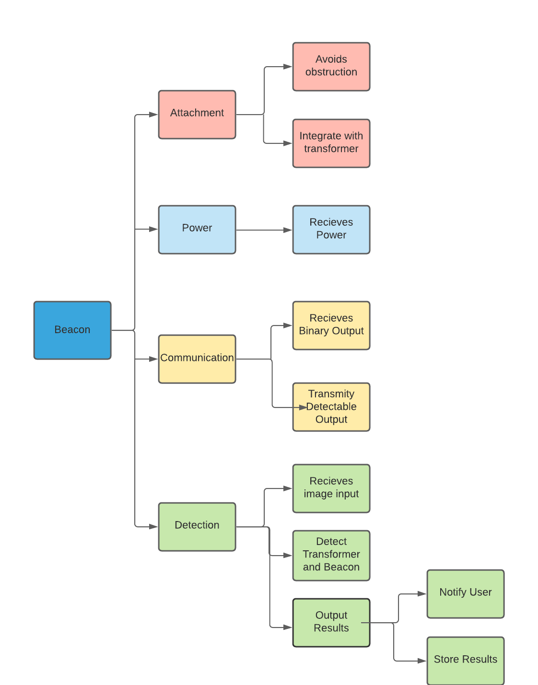
Figure 1

Reasoning
Function Relationships
The functional decomposition hierarchy diagram in Figure 1 displays the “smaller parts” of the original entity into attachment, power, communication, and detection. During the discussion on the functions, the term beacon doesn’t represent a physical object whose sole purpose is to emit light. Rather, it represents how a beacon transmits a signal and how the project’s overall objective is to use a signal to locate what transformer experienced a fault.
The attachment function splits into avoiding obstruction and integrating with the transformer. The beacon itself should be rigidly attached to the pad mounted equipment, as a stationary device. This attachment will integrate with the current transformer design to avoid major changes in appearance and maintain the transformer’s safe exterior. By maintaining the integrity of the transformer, the beacon will not expose the transformer to additional damage from environmental conditions. The function avoiding obstruction acknowledges that there may be objects blocking it from the line of sight of a drone or other autonomous vehicle. This means the beacon’s design has a function of avoiding the maximum amount of potential obstructions so it is clearly visible in different situations.
The beacon device is powered by the current transformer, so its only power related function is to receive this power and connect it to the output. The communication is split into an output signal and an input signal. A black-box device already detects faults within the transformer. This device is not part of the design, but will send power to the beacon when a fault has occurred. This power acts as a binary signal. Once the beacon has received the signal, it will transmit a visual output to be captured by an autonomous drone or vehicle.
The drone will use image recognition to detect the transformer and beacon. This involves first receiving a visual input, in the form of videos or images. The image recognition system is a proof of concept, and therefore doesn’t have to integrate with the current FPL image processing pipeline. It can be assumed that pre-processed visual data will be provided directly to the image recognition model to scan. Once the model has received the input, both the transformers and the beacons will be detected. After a detection has occurred (or hasn’t), the result will be outputted to a user and stored for future use.

Connection to Systems
The functional decomposition cross reference chart displays a comparison of major functions and minor functions based on the hierarchy chart. The X shows relations between major and minor functions, more specifically what minor functions that need to be included for the major function to work. For example, Avoiding obstruction shows dependency upon Attachment and Detection. Meaning, to assure the beacon has a clear line of sight for the drone to detect it while maintaining attachment to the transformer, the beacon’s design must avoid obstructions. From the cross- reference table, the major functions that created the most interconnections are Detection, Communication, and Attachment. Communication and Attachment. These all have the same number of dependencies, so it was decided that Detection will take precedence over the other major functions. This major function relates perfectly to the main objective of the project which is to detect issues with pad mounted equipment.

Team 304: Image Recognition for Pad Mounted Equipment |  | Major Functions
 |  | Attachment | Power | Communication | Detection
Minor Functions | Avoids obstruction | X |  |  | X
 | Integrate with Transformer | X | X
 | Maintains Integrity | X |  |  | X
 | Receives  Power |  | X | X
 | Receives Binary Input |  | X | X
 | Transmits Detectable Output |  |  | X | X
 | Receives Image Input |  |  |  | X
 | Detect Transformer and Beacon | X |  | X | X
 | Output Result |  |  |  | X

Smart Integration and System Crossover
- The minor function of avoiding obstruction relates to attachment and detection because if the beacon is attached in a way that isn’t visible it won’t be possible to do image recognition to find the beacon.
- The minor function of integrating the beacon with the transformer relates to attachment and power because the beacon needs to be attached in a way to also provide it power.
- The minor function of maintaining integrity of the beacon relates to attachment and detection because the attached beacon should not be able to be removed or tampered with by environmental or unintentional means. This would also prevent image recognition from identifying the beacon.
- The minor function of receiving power relates to power and communication because the input signal for the beacon to turn on is the power source.
- The minor function of receiving binary input relates to power and communication because the binary input is the power source.
- The minor function of transmitting a detectable output relates to communication and detection because the output is required to identify if the transformer has encountered a fault.
- The minor function of receiving image input solely relies on detection as without visual data of the area no transformer or beacon can be identified.
- The minor function of detecting the transformer and beacon relies on attachment, communication, and detection because if the system is unable to detect the transformer and beacon it cannot tell if a fault has occurred.
- The minor function of outputting results relies on detection because the end user must know whether a detection has occurred.
Action and Outcome
For the hardware portion of the project, a binary signal will be received by the beacon. That signal is either power or no power. If power is delivered, then the beacon will “turn on” to indicate that there is an issue. Power gets delivered when a fault current is detected. The beacon will then display a signal that the image recognition system will attempt to receive and identify. Visual data will be processed to detect if the beacon is turned on or off. That detection happens through image recognition that will identify both the transformer and the beacon itself. If a beacon is detected, there will be output to an existing FPL system.

